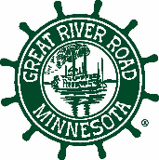
Member Update to MN Mississippi River Parkway Commission
Commissioner: _______________________________________
Representing: ________________________________________
Quarter: _______________________________ _____________

Minnesota

MN Great River Road Corridor Management Plan Implementation Support
Type your Commissioner update here...

State-wide Issue, Project, Event or Partner
Type your Commissioner update here…

Regional

MN Great River Road Corridor Management Plan Implementation Support
Type your Commissioner update here…

Regional Issue, Project, Event or Partner
Type your Commissioner update here…

MRPC – Ten-State

Ten-state Corridor Management Plan Implementation Support
Type your Commissioner update here…

Ten-State Issue, Project, Event or Partner
Type your Commissioner update here…

